Business/Mission
Perlegen Sciences, INC. was a spin-off of Affymetrix in 2000. Perlegen Sciences (Perlegen) mission was to discover the mystery of causal relationships between human genes and diseases and to work with pharmaceutical companies to develop cures for these diseases. It pursued this mission by working with the best genetic scientists to analyze human’s gene and finding out unique genetic variations patterns, single nucleotide polymorphisms (SNP). These SNPs could explain why different individuals development different diseases, which then would be used by pharmaceutical companies to produce medicinal cures. Perlegen was working on a Genome Scanning Project (GSP), a research activity that aims to find out ways to scan the entire genome from several individuals in a relatively short period of time at a relatively cheap cost.

Internal Organizational Strengths and Weaknesses

Operational Strengths and Weaknesses
Perlegen’s main operational strength was the smooth cooperation between the managers and scientists. Brad Margus, CEO of Perlegen, and David Cox, Chief Scientific Officer, made most major decision as a team. As a result, research at Perlegen was conducted not only with a scientific agenda, but with a business perspective in mind as well. Cooperation was strong between not only the business and science departments, but between the science and engineering. Managers from each of these departments took many steps to foster cooperation. Perlegen was also open to expertise and advice from outside, which clearly would increase its competitive advantage.
Regardless, Perlegen was planning to increase its employees from 22 to 125 people within a short period time (18 months), coordination and cooperation between the business managers, scientists, and engineers may become a problem because of the drastic expansion within the company. Perlegen’s plan to develop its own drug program would adversely affect the relationship with its primary customers: pharmaceutical companies. Furthermore, Perlegen currently does not have the pharmaceutical expertise to develop its drug program.

Human Resources Strengths and Weaknesses
Brad Margus was definitely a strength in terms of human resources. He had passion for his job due to experiences within his immediate family. His management background helped play a very important role in the successful growth and expansion of Perlegen. The world-renowned scientist, David Cox, was also an invaluable asset for Perlegen. Brad and David worked together to recruit many well-known people in the business and science world, adding more strength to its human resources field.
Perlegen’s recruiting philosophy was also critical for its successful operation. It recruited people who “want to have an impact”, not people look for compensation, prestige, or other things. Perlegen was not only good at recruiting but also at retaining good employees. Perlegen willingness to make specific accommodations for its employees was its secret.
Involving employees in decision-making process was another one of Perlegen’s HR strengths. By doing this, it was able to implement some work which otherwise would be opposed by employees. The company’s open door policy also made employees feel free to give suggestions and motivate one another. A final motivator was the issuance of stock options to every full time employee.
Beyond these strengths, Perlegen did have some problems. As opposed to most start up companies, Perlegen had many mid-level positions filled before it hired the senior management team. This could cause cooperation or management problems between the “experienced but mid-level employees” with the “new but senior level managers.” The lack of training in biology for new manager could also create more problems and tensions within Perlegen.
Hiring Cox’s previous student, at one time, brought scientific talents into Perlegen. On the other hand, it created the possibility of forming power group (David and his students versus other employees, for example, the new CIO). Outside of the social aspects of human resources, the lack of an executive bonus plan was a disadvantage as many of their competitors offered such programs.
Being too dependent upon Margus and Cox can also be a problem. Margus and Cox were spiritual leaders within the GSP project. When they were not in office there was a sense of anxiety in the organization. Compensating for this could prove to be a major challenge for new senior managers.

Technology and Research and Development Strengths and Weaknesses
Perlegen had exclusive right to access Affymetrix’s high-density wafers, the first step to analyze human genes more efficiently. If Perlegen’s GSP succeeds, it would be a revolution in genetic analysis. A second technological strength is that there are many world-renowned scientists and engineers in Perlegen.
Even so, Perlegen was in first development stage in the GSP project and there was still significant risk in the project. For example, Perlegen needed to develop new automation techniques and other instruments for the GSP. Additionally, storage capacity was not enough for the GSP because of tremendous scale of data that would be collected (approximately 500 terabytes).

Accounting/Finance Strengths and Weaknesses
Financial management at Perlegen was smart in that it looks to increase revenues for the company while still cutting costs. Perlegen could easily raise money to expand its business. In fact, it refused some investments in order to stick with its original financial plans. Regardless of amount of money Perlegen was able to raise, even the top-level managers emphasized the importance of reducing costs with every employee. So, Perlegen was squeezing out every possible unnecessary cost to reduce costs and increase profit.
Perlegen was a private company which had its own advantages and disadvantages compared to public companies. The visibility of well performing public companies can attract more future offerings than the invisible private companies. Perlegen also lost the opportunity to use public traded securities to finance acquisitions. So being private may not be good for future expansion. On the other hand, Perlegen also enjoyed the advantage as a private company. It was not required to disclose its accounting/finance or other sensitive information to outsiders.

Cross Functional Issues
Human Resources & Operations
First, there is a positive chainlike relationship between human resources and operations. In many biotechnology organizations there is tension between biologists and software engineers because they do not trust each other. Unlike these organizations, Perlegen had close working relationships between its science and technical teams. The bioinformatics manager, John Rachlin, encouraged his members to overcome this lack of trust on an individual basis and established the ground rules for open and frequent two-way communication. He told the members of the informatics group to talk to scientists on a daily basis to understand exactly what they were doing. Due to this frequent communication, the technology group was able to be one step ahead in the development of projects for the scientific group. These good policies from human resource management also smooth the operating procedures and make the company run more efficiently.
Second, I will mention the negative chain of cross functional issues. Even though each department does not have current conflicts, we can anticipate they may have conflicts in the future, for they are expanding rapidly. Since Perlegen planned to grow from 22 to 125 people within 18 months, they may have conflicts between functional areas during the transitional period if they do not have a sound communications channel to handle the growing numbers of employees.
Third, since middle and junior-level employees were hired before hiring senior managers, if Perlegen does not efficiently integrate new senior managers into the existing organization, Perlegen could face inefficiency in operations.
Research & Development and Finance
In a start-up biotech company, major financial resources come from outside venture capitalists. Thus, the financial condition of a start-up bio-venture company depends on timely fund raising. The Perlegen’s genome project was popular and attracted many investors. The company primary focus is on the relationship between genetics and disease. Through the identification of genetic profiles that drive drug response, Perlegen would be able to quickly bring safer and more effective medicines to market. In other words, the time between genetic discovery and helping patients is quite rapid. This cutting edge technology and prospective R&D process allowed Perlegen raise $100 million within a six-week period, the amount that is needed for Phase 1 of their business plan. However, if they delay or fail in the R&D process in their first attempt, it may become difficult to raise capital during the second round of fundraising. Statistically, when a drug fails late in the development stage, the value of the company's can plummet. Since the company is in the first stage of GSP project, they cannot guarantee the success of their research. Perlegen’s future financial condition will be based upon whether they can maintain their competitive advantage in R&D.
Operating and Research & Development
Affymetrix developed a technology with Perlegen that allowed them to put more probes on a chip than anyone else. From operating perspective, Perlegen could gather data more quickly, and in turn, analyze and generate results more rapidly as well.

Opportunities and Threats
First, the amount of capital invested in biotechnology has soared in recent years. This can be attributed to recent technological advances and a change in viewpoint about these companies from investors. This will make future fundraising efforts much easier than before. Second, the need for medical treatment is increasing, because of population growth and people living longer. Additionally, there are still many diseases that cannot be cured, such as A-T, the disease that affected the Margus family. Third, the product life cycle is long. The patent law protects the innovation of new drug at least 20 years. As long as the company has a new drug with efficacy, future revenues should be substantial.
Even though the future looks promising, potential threats must be evaluated as well. The number of U.S. biotechnology firms has continued to climb, approaching 1,500 in 2001. This evaluates to increased competition. To make things worse, the costs associated with the development of a new drug are substantial and the risk of a drug failing in the developmental stage is always high. In the future if Perlegen were to go public, it must think about the adverse effects that can result from a drug failing. A company’s stock price may decrease by 60% in one day if their drugs clinical tests fail. For example, the BetaKine of Celtrix Pharmaceuticals Company failed in the third stage of clinical test. The stock price decrease by 63% and resulted in 47% of their employees being laid off. Needless to say, the biotechnological industry is extremely risky.

Key Issues
As a biotech start-up company, Perlegen has aggressive goals. Within 18 months, Perlegen planned on not only expanding the organization from 22 employees to 125 employees, but also planned on finishing phase 1 of their business plan which is to identify common patterns in which SNPs occur. Based on the previous analysis, we developed three key issues that must be addressed before Perlegen can succeed.
Two of the key issues we developed are related to human resources and operational issues; how to build a new organization to encourage cross-functional cooperation aligned with a new expanding venture strategy. From these issues, we developed two issues that are key to Perlegen’s success; 1) Vertically, how to integrate the CIO as a new senior manager? 2) Horizontally, how to coordinate each functional area? Perlegen hired a number of junior-level and mid-level employees, and now it is time to fill out the senior management team. Margus's first senior management hire was Greg Brandeau, CIO. Thus, the vertical integration of CIO and horizontal cooperation in rapidly growing organization will be used as a template for future expansion and coordination.
Another issue is an R&D and technical issue; 3) How to maintain their R&D competitive advantage? Since Perlegen will be scanning an unprecedented amount of data, their information storage infrastructure must be expanded. This could pose many challenges for Perlegen’s technical staff, and in the long-term they may not be able to handle every problem presented to them.
In the following section, we will discuss possible alternatives and evaluation about two HR and organizational issues and the R&D and technical issue. Each issue will have two alternatives, and then each alternative will be evaluated.

Alternative Solutions and Evaluations (Exhibit 1. Summary of alternatives)
Key Issue 1: Vertically, how to integrate the CIO as a new senior manager?
Placement of Greg Brandeau in the organizational structure of Perlegen is extremely important. The other two current executives, Margus and Cox, are consistently out of the office, leaving Brandeau to run not only the IT department, but the organization as a whole. To maintain stability within the organization we have developed two alternatives to address this problem.
One alternative (Exhibit 2) is to keep your current organization as planned. In this system, CIO’s position is same level with a Scientific Director. Both Brandeau and Cox would be in charge of their respective departments. If Perlegen chooses this hierarchy, roles would be clearly defined and differentiated. However, since this kind of system does not have any type of communication channel between the science team and the technical team, it could cause conflicts between the two teams; which is a common occurrence at other biotech companies. Another disadvantage is that it would take more time for the new CIO to adapt to the existing corporate culture and to understand the business. Additionally, because Brandeau lacks a scientific background, he may become isolated working in the IT department and could have difficulty understanding Perlegen’s business as a whole.
A different alternative (Exhibit 3) would be putting the CIO’s position directly under the Science Director. In this hierarchy more authority would be given to the CIO. Also the CIO would act as a bridge between both the R&D and IT staffs. Regardless of the positives, this vertical system could cause inefficiency during the transitional period directly after Brandeau begins work. In order for this system to succeed, a close relationship between the Science Director and the CIO is paramount.
Key Issue 2: Horizontally, how to coordinate between each functional area?
Inter-department organization, communication and coordination are integral in the efficiency and productivity of the company as a whole; and as a company grows, the difficulty of performing these tasks grows as well. In order to provide these lines of communication we have developed several alternatives. Our first alternative is that Perlegen just empower some managers that would coordinate each team without an organizational support system, similar to the current structure. The advantage of this alternative is that it requires low initial investment; however, since Perlegen has planned for a rapid increasing in the number of employees, over 5 times the current amount within 18 months, this solution could cause communication problems between functional areas and inefficient organization in the long run.
Our second alternative is to build an “enterprise information portal site.” Since sharing knowledge is a critical issue to knowledge–based businesses, the enterprise information portal would give your organization a multitude of benefits. The portal would provide a single point of access to the firm’s knowledge bank which includes access to external sources of information, such as news feeds and research, as well as internal knowledge resources for e-mail, e-learning, discussion groups, and conferencing. Appendix 4 shows an example of contents in an “enterprise information portal site.” Once in place this portal site would facilitate communications, collaboration, coordination and the sharing of knowledge. In the long run, this portal would assist in the detailed cost-management of the organization. To test the feasibility of this endeavor, we should calculate the financial burden that implementing such a system would be. To accomplish this we will calculate the cost-benefit ratio of the portal system. We will consider the endeavor to be acceptable if the cost-benefit ratio is over 1. The following table shows the estimated costs and the according cost-benefit ratios.
 | Optimistic estimation | Pessimistic estimation
Benefit | Labor costs saved for 12 employees  (10% = 12 / 125) | Save labor cost for 9 employees  (8% = 9 / 125)
Cost-benefit ratio | 70,000 * 12 * 1.5 / 1 million = 1.26 | 70,000 * 9* 1.5 / 1 million = 0.95

The above calculations were made under the assumptions that the optimistic estimation will provide 10% labor cost savings and the pessimistic estimation will provide 8% labor cost savings. We also estimated the budget for this investment to be $1,000,000. Additionally we assumed that the average wage for a middle-layer scientist and IT expert to be $70,000 per year and within 18 months, the total number of employees to be 125. If we assume other invisible benefits such as efficient coordination between each functional area and sharing of knowledge, even the pessimistic evaluation leaves Perlegen with reasonable outcome.
Key Issue 3: How to maintain their R & D competitive advantage?
Although the size of DNA information is finite, it is still overwhelming. Perlegen estimated that they will need to store approximately 500 terabytes of information within the first eighteen months of service (Nearly 10 terabytes of information per genome). Processing and storing this vast amount of data is no easy task, as incorrect data storage could potentially jeopardize the entire operation. The development of such a complex data infrastructure is no easy task, and we must anticipate problems that could arise.
Our first alternative to solve our data storage problem is to contract an outside company to manage and store the data. This would remove a major burden from the IT department, as they would no longer have to design, develop, and maintain the intricate storage system that is needed. This system could also be more stable, as it is being maintained by storage professionals, although this may also lead to possible security breaches by employees of the storage provider. The drawback of this alternative is that the amount of data transfer that is going to be required by Perlegen’s system would travel much too slow, as the data center would be off-site.
To solve this latency problem, our second alternative uses a different approach: building a data storage and processing center on-site. This system would have to be able to allow for the short-term storage, analysis and long-term storage of the massive amounts of data collected. Data would run from first scanning to analysis to storage in a queue-like manner. To handle these various needs, a multi-tiered data storage infrastructure would be needed. This new data storage center would consist of four major components: a database, an array of fast hard disks, a processing center, and a tape-drive center/server. This alternative would provide fast and efficient storage, but at the same time would be expensive to design, implement, and maintain.
Both of our previous alternatives deal only with the short-term needs of the company, which are getting the data processing and storage infrastructure up and running. Beyond the short-term though, Perlegen may run into other complications as their business grows. To assist in dealing with these potential business hazards we recommend forming an advisory board, similar to the scientific advisory board, that will be there in times of need to give advice and to solve technological problems that the Perlegen staff cannot handle.
Recommendations
Perlegen is at a level in their business development that there are many critical decisions must be made to ensure success, prosperity and long-term sustainability. In the following section we will address the three aforementioned key issues and give our recommended solutions. We will begin with key issue 1: Vertically, how to integrate the CIO as a new senior manager?
We recommend the implementation of our second alternative, to place the CIO directly below the Scientific Director. Placing the CIO in this location within the hierarchical structure would quickly provide an essential communications link between the R&D and IT departments. This connection would serve two purposes. First, Brandeau would be able to act as the guiding management figure, alleviating the feeling of insecurity that occurs when Margus and Cox are not present. This would also install a new sense of confidence and encouragement that was previously lacking, and will surely bring an added feeling of “we can do it” throughout the organization. Second, the issue of “engineers not being able to talk with scientists” would be no longer be present as Brandeau would provide the lines of communication between the two departments. Once the upper management CIO role has been positioned accordingly, interdepartmental issues can be addressed. This brings us to Perlegen’s second key issue: Horizontally, how to coordinate between each functional area?
When addressing the issue of cross-departmental coordination we feel that the optimal solution involves the development of an enterprise information portal. This portal would assist in the coordination of company wide activities. Employees would now have a single point of access to the Perlegen’s knowledge bank which includes access to external sources of information, such as news feeds and research, as well as internal knowledge resources such as e-mail, e-learning, discussion groups, and conferencing. A centralized information server would increase interdepartmental coordination and communication, and in the long-run save the company money; however, this portal requires a large initial investment.
Our solutions to key issues one and two both deal with organizational structure and human resources and will provide a valuable contribution to the company, but Perlegen itself cannot function unless an information infrastructure has been built. This brings us to our third and final key issue: How to maintain their R&D competitive advantage? In order to be able to handle the massive amounts of data collected from the genetic analysis, it becomes apparent that a fast and reliable data infrastructure must be installed. To do this, we recommend our second alternative which is to implement a multi-tiered database, processing, and storage center on-site. This would provide fast, secure, and efficient access to information, all of which are key factors if Perlegen is to succeed in its goal of analyzing 50 genomes within the first 18 months of operation. The implementation of Perlegen’s storage structure would be as follows. Data would run from first scanning to analysis to storage in a queue-like manner. Initially, data would be read from the scanning equipment, from which it would be stored in a fast access hard disk buffer system. A database system would be used to track the location of each image, as well as its processing status. This system would keep approximately five terabytes of data, and because of the use of a database, data retrieval would be extremely fast. The next step is the processing stage. Processing would take place on a network of computers dedicated to analyzing and storing information on the processed images. Once the data has been processed it is no longer needed for the current analysis and therefore can be stored in a large-scale, long-term storage system. Because data that has been stored in the long-term facility is not frequently accessed, speeds for retrieval are not as important. An estimated 500 terabytes of information are expected to be stored within this system. After considering retrieval time requirements as well as storage size requirements we recommend the usage of a tape-drive server and storage system that would be monitored by the main database system. Although this system may have high initial costs, it would run much faster than an off-site facility and would be more secure.
Lastly we recommend that Perlegen establish a board of advisors for the technology division. The immense amount of work ahead of the technology group is overwhelming. The board of advisors would take a role similar to the board of advisors for the scientific group, but would be smaller in scale. This would ensure long-term continuity and guidance for Perlegen.

Appendix 1: Summary of alternatives

Key issues |  | Alternative 1 | Alternative 2
HR and  Operations | Vertical  integration | Same level between Scientific director and new CIO | Place CIO under Scientific Director
HR and  Operations | Horizontal  collaboration | Just to empower some managers | To build Enterprise Information Portal
Research  And  Development | Short Term | Outsource storage needs | Build multi-tiered hierarchical database and storage structure
Research  And  Development | Long Term | Establish board of advisors from outside experts

Appendix 2. New vertical organization chart - Alternative 1
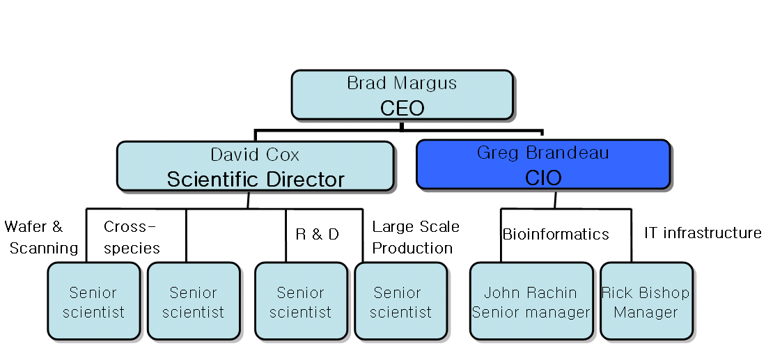

Appendix 3. New vertical organization chart - Alternative 2

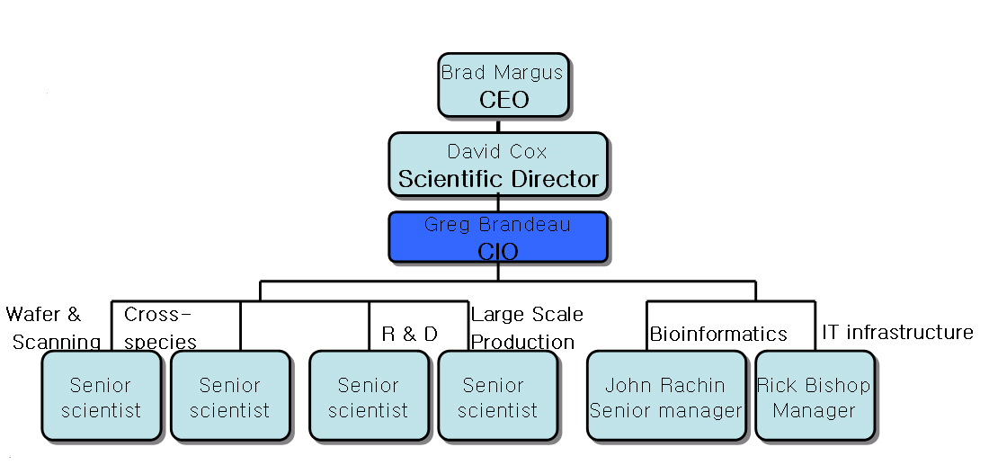

Appendix 4. An example of contents in “enterprise information portal site”

